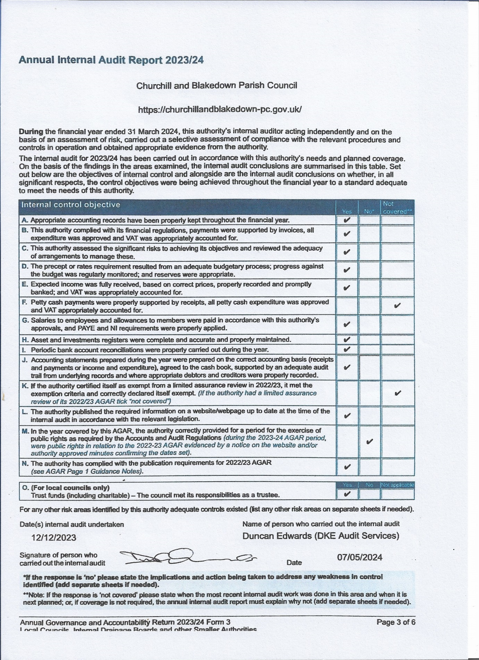

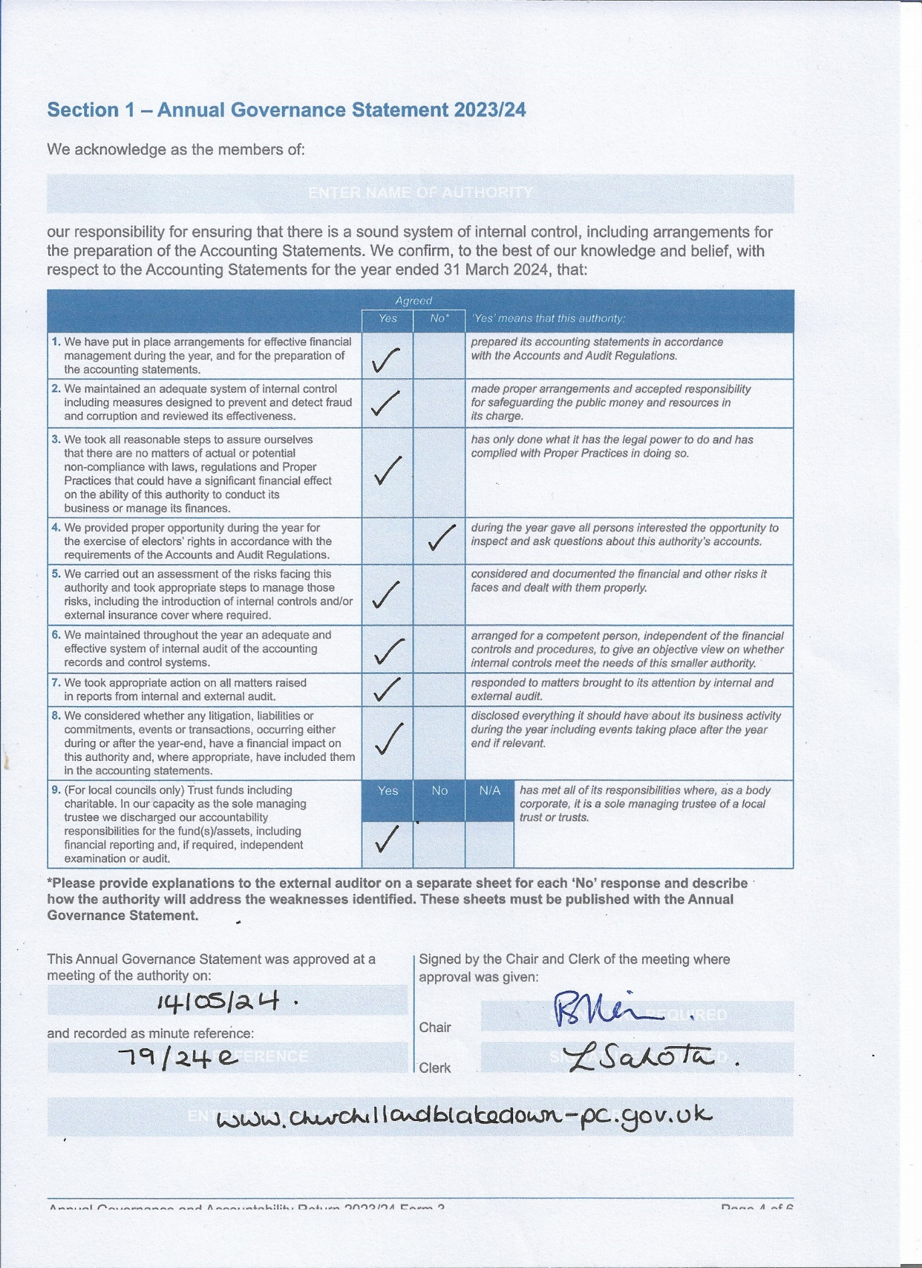

Section 1 – Annual Governance Statement 2023-24
Explanation for Assertion No 4 being declared as ‘No’ – the clerk published the Notice of the period for the exercise of public rights for 30 calendar days instead of 30 working days.
This has been corrected this year however in the interests of transparency and accountability, this has to be declared as No for the submission made for the previous year.

